**Cat :**

Cat command is very frequently used in Linux.

It reads data from the file and gives their content as output.

It helps us to create,view,concatenate files.

Some frequently used cat commands :

1) $cat filename --> To view the content of given file

2) $cat -n filename --> It shows the content with line number in given file

3) $cat >newfile --> It will create a file and name it as newfile

4) $cat file1 >> file2 --> It will append the contents of file1 to the end file2

5) $cat -E "filename" --> It will highlight the end of line

6) $cat *.txt --> It will show the content of all text files present in the folder

7) $cat file1 > file2 --> This copies the content to the destination file2

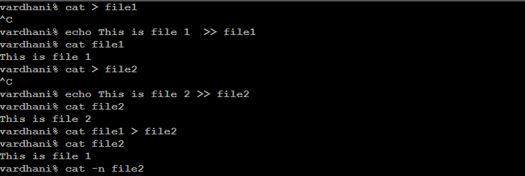**Grep :**

The grep command is used to search text .

It is a command line utility for searching plain text data sets for lines that match a regular expression.

It is one of the most useful commands on linux.

Examples of grep commands:

1. $ grep “[a-e]” file1 --> match all lines that contain any of the letter a,b,c,d,e
2. $ grep “[^aeiou]” file1 --> match all lines that do not contain a vowel
3. $grep -I “hello” file1 --> match all lines that contain the word hello in upper or lower case
4. $grep “^hello” file1 --> match all lines that start with hello.

­­­­­­­­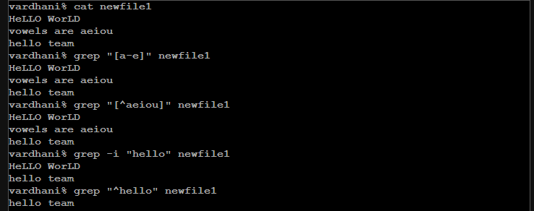

**Pwd :**

**Pwd** command is a command line utility for printing the current working directory .

It will print the full system path of the current working directory to standard output.

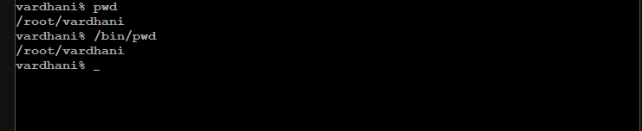

**Mkdir :**

**The mkdir** command in Linux allow users to create or make new directories .

Mkdir stands for Make directory.

With mkdir , you can also set permissions , create multiple directories at once and much more

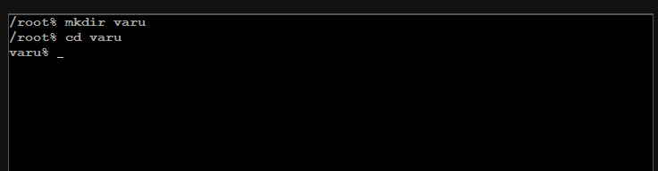

**Ls :**

**The ls** command is a command line utility for listing the contents of a directory or directories given to it via standard input.

It writes results to standard output.

The ls command supports showing a variety of information about files,sorting on a range of options and recursive listing.

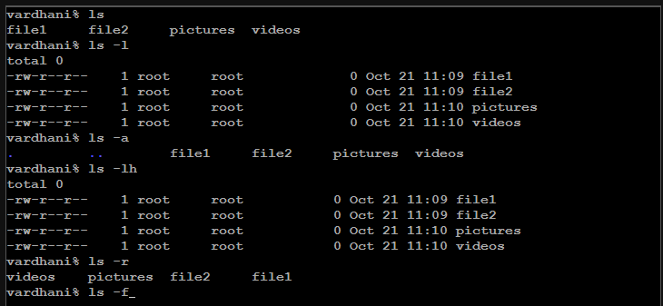

Cd :

The cd command is also know as chdir i.e; change directory , is a command line shell command used to change the current working directory in various operating systems.

It can be used in shell scripts and batch files.

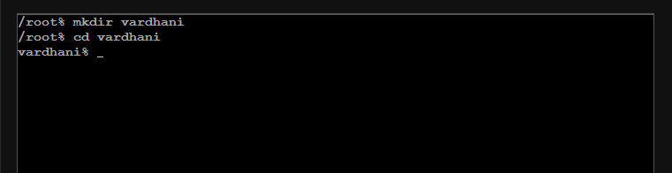

**Man :**

**Man** command in Linux is used to display the user manual of any command that we can run on the terminal.

It provides a detailed view of command the command which includes name,synopsis,description,options,exit status,return values,errors,files,versions,examples and also authors.

**Chmod :**

Chmod in Linux is a command and system call which is used to change the access permissions of file system objects.

It is also used to change special mode flags.

